**BASH SCRIPTING**

1) Write a shell script to run the following operations by reading 2 numbers and one choice from the user:

* Addition
* Subtraction
* Multiplication
* Division
* Average
* Script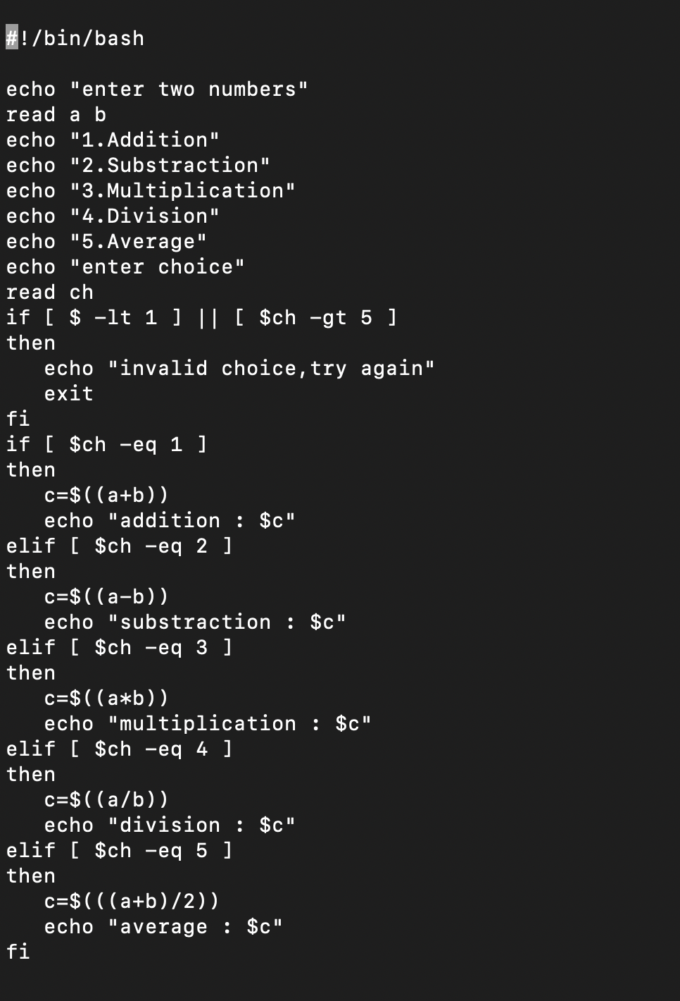OUTPUT
* 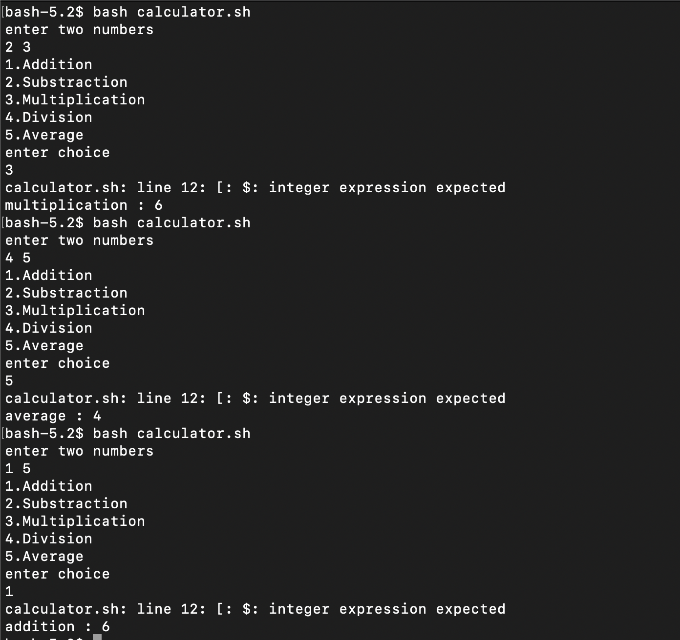
* 2) Write a shell script to check whether a number is a palindrome or not
* 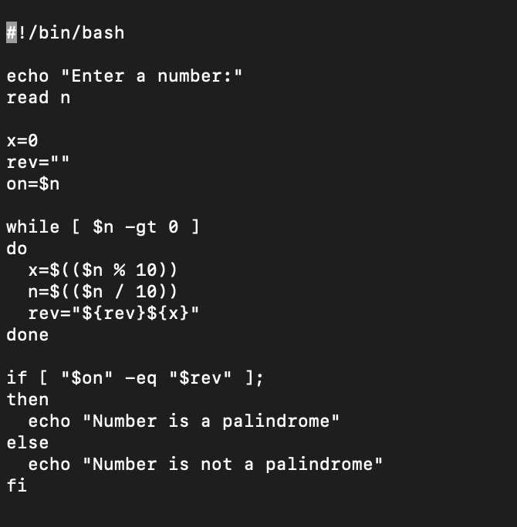
* OUTPUT
* 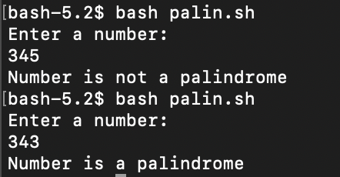
* 3) Write a script to run the following operations by reading an input and a choice from the user:
  + ROT13 Encode
  + ROT13 Decode
  + 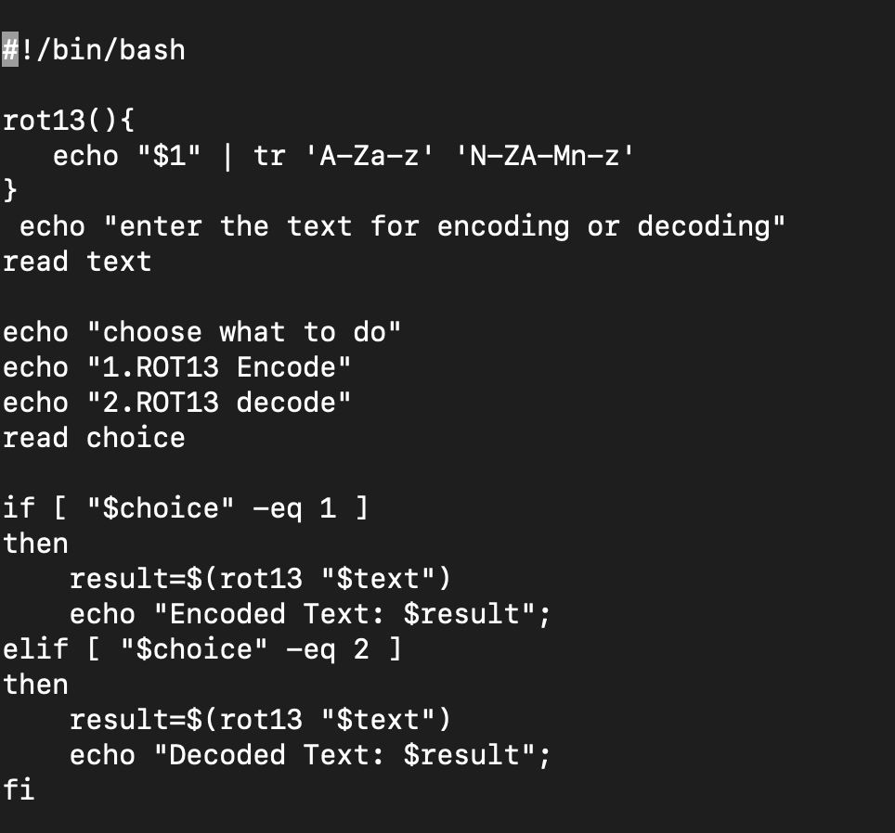
* OUTPUT
* 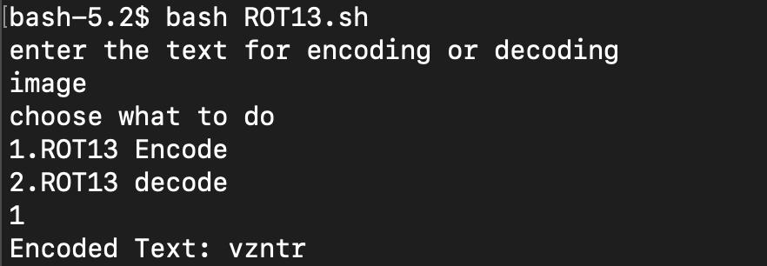
* 4) Using functions, write a shell script program to check whether a file named “persistence” is present in your system.
* CODE
* 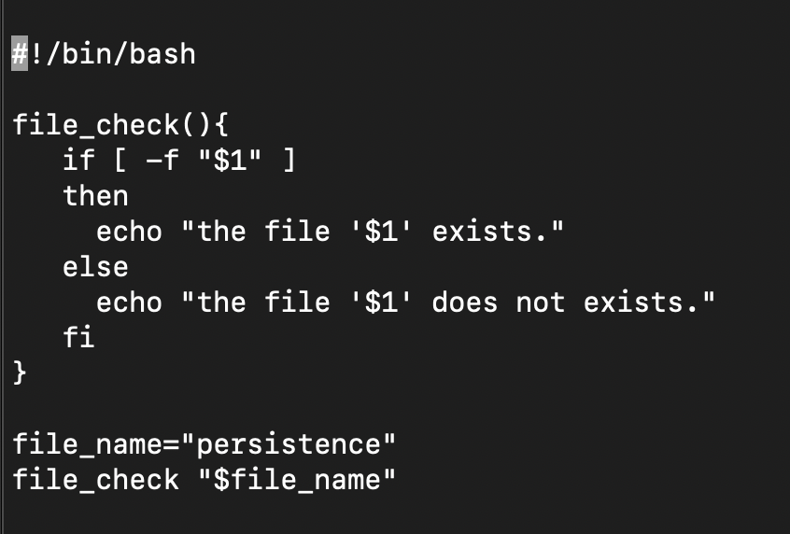
* OUTPUT
* 